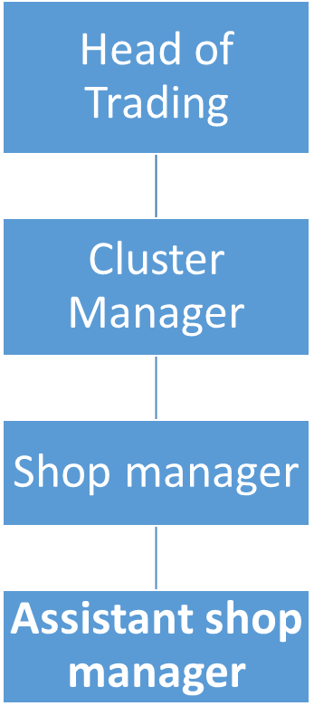
Job Role Profile
Title
Assistant Shop Manager – St Ann’s Altrincham Shop

Salary
£23,615 pro rata

Location
17 Stamford New Road, Altrincham, WA14 1BN

Responsible for
Supporting the Shop Manager with daily operations

Responsible to
Shop Manager

Core Purpose
Provide excellent customer service and maximise sales
Job summary

As an Assistant Manager you will support the Shop Manager and be an integral part of a small team responsible for handling donations, pricing items, and creating appealing displays. Your role will encompass various responsibilities to ensure the smooth operation of the shop and provide an exceptional customer experience.

Your role will be essential in maximizing sales, providing outstanding customer service, and leading a dedicated team of volunteers.

Your efforts will directly contribute to our mission of delivering first-class palliative and outpatient care at both of our Hospices.

Responsibilities

The Assistant Manager will –

- Provide exceptional customer service, and handle enquiries in a timely & professional manner.
- Boost sales through effective merchandising and promotional activities.
  - Foster a positive and inclusive environment for volunteers, whilst assisting in their recruitment, training & supervision.
  - Keep the shop clean, organised and visually appealing.

- Work towards daily and weekly sales and income targets with the support of the Shop Manager

- Respond to donor enquiries both on the phone and online.

- Promote the Gift Aid scheme on all donations.

- Support the Altrincham Shop Manager and cover absences.

- Identify stock for sale online in conjunction with the online manager

Skills and Experience

The Assistant Manager will –

- Be educated to GCSE level or equivalent

- Have a proven track record of delivering exceptional customer service.

- Evidence excellent verbal and written communication skills, with proficiency in Microsoft Office Suite.

- Have experience using social media platforms, such as Facebook and Instagram with confidence in assisting in the creation of engaging content.

  - Experience working in a charity shop or non-profit organization is a plus.

  - Support the Shop Manager in daily operations, including, but not limited to, opening and closing procedures, managing the shop email account, maintaining health & safety standards.

  - Support the Shop Manager in creating engaging social media content, as well as collaborating on marketing strategies to promote the shop and its products.

  - Manage stock, both donated & new; researching, pricing & promoting as required.

- Attend monthly 121 meetings with Manager to review targets and areas for growth

- Support and motivate a small team of volunteers

- Ensure all Health & Safety checks are completed.

- Demonstrate a keen understanding of clothing brands & fashion trends, with the ability to identify high-value items.

- Display strong organizational skills and meticulous attention to detail.

- Be an effective collaborator, with the ability to work well in a team environment.

- Be willing to work flexible hours, including weekends when required.

Any post holder within the organisation will be expected to undertake safeguarding training appropriate to their role and adhere to safeguarding policies and procedures. All staff must work in accordance with their statutory roles and responsibilities in relation to safeguarding in accordance with the Working Together to Safeguarding Children 2023, The Care Act 2014, and Prevent Duty 2015.

Terms and conditions for the Assistant Shop Manager
Contract
Permanent

Work Pattern
2 days (15 hours), variable Mon-Sat.

Location
17 Stamford New Road, Altrincham WA14 1BN

Holiday
35 days, increasing to 37 days after 5 years’ service and 41 days after 10 years’ service (pro rata, inclusive of bank holidays). In addition staff are able to buy up to 1 weeks’ holiday per year via salary sacrifice, pro rata.

Pension
Contributory Stakeholder pension in which we match up to 7% of your gross salary. Or the ability to continue with a previously held NHS pension (subject to making contributions into the scheme in the previous 12 months).

Life Cover
All staff in the Scottish Widows Pension scheme (with the exception of bank staff) are provided with life cover of three times their basic salary in the event of their death whilst employed by St Ann’s Hospice.

Health Cash Plan
We offer access to an employee paid health cash plan. That allows employees to spread the cost of health expenses including dental, optical, physiotherapy and more.

Employee Assistance Programme
Employees can access telephone and online counselling 24 hours a day. Face to face counselling is also available and support on issues including debt, employment law, benefits and housing.

Probation
Six months

Notice
4 Weeks

